HELM & HELM CHART

What is Helm
- Helm it’s a tool that automates the creation, packaging, configuration, deployment of k8s application by combining your configuration files into a single reusable package.
- helm chart helps you to define, install, even upgrade the most complex Kubernetes applications.

INSTALLATION OF HELM
$ curl -fsSL -o get_helm.sh https://raw.githubusercontent.com/helm/helm/main/scripts/get-helm-4
$ chmod 700 get_helm.sh
$ ./get_helm.sh
$ helm version
{ v4.1.0 }

CREATING OUR OWN HELM CHART ==>> (APACHE)
- helm create apache-helm
- cd apache-helm
- ls
chart.yaml charts/ templates/ values.yaml
All manifests’ files are stored in the templates/
- deployment.yaml
- service.yaml
- ingress.yaml
- hpa.yaml
All values are defined in values.yaml
replicaCount: 2
image:
repository: httpd
tag: "2.4"
service:
type: NodePort
port: 80
targetPort: 80
nodePort: 30080
Change in the templates/service.yaml file
add nodeport section below name section
{{- if eq .Values.service.type "NodePort" }}
nodePort: {{ .Values.service.nodePort }}
{{- end }}
All info about the packages are stored in chart.yaml
- To detect YAML syntax errors and template issues before deployment.
helm lint apache-helm

- Preview the Generated Manifests
helm template dev-apache apache-helm
- Generates a compressed .tgz file that can be shared or uploaded to a Helm repository
helm package apache-helm

- To deploy the application into the Kubernetes cluster.
helm install dev-apache apache-helm
- kubectl get pods
- kubectl get svc
- kubectl get deployments
- To deploy the application into the Kubernetes cluster.
helm upgrade dev-apache apache-helm

- To see all Helm releases installed in the current namespace.
helm list
- To check the history of revisions
helm history dev-apache
- To inspect the current state of a Helm release.
helm status dev-apache

- To check which values were used during installation or upgrade.
helm get values dev-apache

TO ROLL-BACK
- Rollback to revision 1
helm rollback dev-apache 1

- To check all the history of dev-apache revision
helm history dev-apache

- To remove the application from the Kubernetes cluster.
helm uninstall dev-apache

ASSIGN A NAMESPACE TO A CHART
- helm install dev-apache apache-helm -n dev --create-namespace
- kubectl get pods -n dev
- helm install prod-apache apache-helm -n prod --create-namespace
- kubectl get pods -n prod

DEPLOY STUDENTAPP APPLICATION
- helm create studentapp
- cd studentapp
- vim templates/service.yaml
add one line after targetport {{ .Values.service.targetPort }}
- vim values.yaml
replicaCount: 2
repository: mayurpandit25/student-app
tag: "latest"
port: 8080
targetPort: 8080
- cd ..
- helm package studentapp
- helm install dev-studentapp studentapp -n dev-student --create-namespace
- kubectl get pods -n dev-student
- kubectl get svc -n dev-student
- kubectl port-forward svc/dev-studentapp 8080:8080 --address=0.0.0.0 -n dev-student
<http://<public_ip:8080>

DEPLOY THREE-TIER APPLICATION USING HELM (EASY-CRUD)
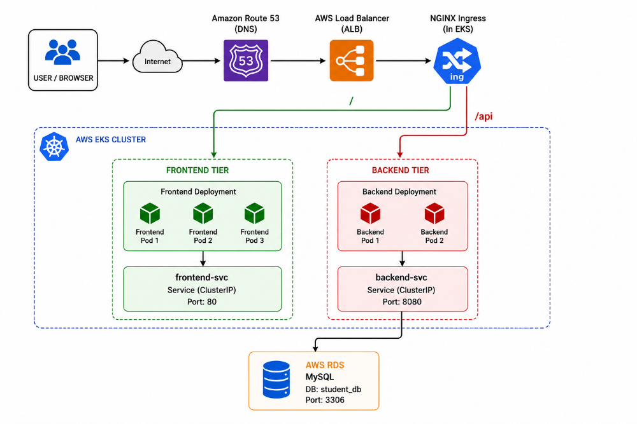
1.create a RDS (MySQL) database
ON BACKEND
- access the server
- apt update
- apt install mysql-client
- mysql -u admin -h <endpoint> -p
- create database student_db;
- git clone https://github.com/mayurpandit25/EasyCRUD.git
- cd EasyCRUD/backend/src/main/resources
- vim application.properties
- Endpoint:
- User:
- Password:
- docker build -t mayurpandit25/cbz-backend:latest .
- docker push mayurpandit25/cbz-backend:latest
ON FRONTEND
- cd frontend
- vim .env
VITE_API_URL=/api
- docker build -t mayurpandit25/cbz-frontend:latest
- docker push mayurpadit25/cbz-frontend:latest
USING HELM
- helm create easycrud
- cd easycrud
- cd templates
- rm -rf *
- vim Chart.yaml
apiVersion: v2
name: easycrud
description: Three Tier Application Helm Chart
type: application
version: 1.0.0
appVersion: "1.0"

- vim values.yaml
backend:
replicaCount: 2

image:
repository: mayurpandit25/cloudblitz-backend
tag: v1
pullPolicy: Always

service:
type: ClusterIP
port: 8080
targetPort: 8080

frontend:
replicaCount: 1

image:
repository: mayurpandit25/cloudblitz-frontend
tag: v1
pullPolicy: Always

service:
type: ClusterIP
port: 80
targetPort: 80

ingress:
enabled: true
className: nginx

host: app.mayurcbz.space

frontendPath: /
backendPath: /api

- vim backend-deployment.yaml
apiVersion: apps/v1
kind: Deployment
metadata:
name: backend
spec:
replicas: {{ .Values.backend.replicaCount }}
selector:
matchLabels:
app: backend
template:
metadata:
labels:
app: backend
spec:
containers:
- name: backend
image: "{{ .Values.backend.image.repository }}:{{ .Values.backend.image.tag }}"
imagePullPolicy: {{ .Values.backend.image.pullPolicy }}
ports:
- containerPort: {{ .Values.backend.service.targetPort }}

- vim backend-service.yaml
apiVersion: v1
kind: Service
metadata:
name: backend-svc
spec:
type: {{ .Values.backend.service.type }}
selector:
app: backend
ports:
- port: {{ .Values.backend.service.port }}
targetPort: {{ .Values.backend.service.targetPort }}

- vim frontend-deployment.yaml
apiVersion: apps/v1
kind: Deployment
metadata:
name: frontend
spec:
replicas: {{ .Values.frontend.replicaCount }}
selector:
matchLabels:
app: frontend
template:
metadata:
labels:
app: frontend
spec:
containers:
- name: frontend
image: "{{ .Values.frontend.image.repository }}:{{ .Values.frontend.image.tag }}"
imagePullPolicy: {{ .Values.frontend.image.pullPolicy }}
ports:
- containerPort: {{ .Values.frontend.service.targetPort }}

- vim frontend-service.yaml
apiVersion: v1
kind: Service
metadata:
name: frontend-svc
spec:
type: {{ .Values.frontend.service.type }}
selector:
app: frontend
ports:
- port: {{ .Values.frontend.service.port }}
targetPort: {{ .Values.frontend.service.targetPort }}

- vim ingress.yaml
{{- if .Values.ingress.enabled }}
apiVersion: networking.k8s.io/v1
kind: Ingress
metadata:
name: three-tier-ingress
spec:
ingressClassName: {{ .Values.ingress.className }}
rules:
- host: {{ .Values.ingress.host }}

http:
paths:
- path: {{ .Values.ingress.backendPath }}
pathType: Prefix
backend:
service:
name: backend-svc
port:
number: {{ .Values.backend.service.port }}
- path: {{ .Values.ingress.frontendPath }}
pathType: Prefix
backend:
service:
name: frontend-svc
port:
number: {{ .Values.frontend.service.port }}
{{- end }}

INSTALL INGRESS
1. kubectl apply -f https://raw.githubusercontent.com/kubernetes/ingress-nginx/main/deploy/static/provider/aws/deploy.yaml
2. kubectl get pods -n ingress-nginx
3. kubectl get svc -n ingress-nginx

START DEPLOYMENT
- helm lint easycrud
- helm template studentapp easycrud
- helm package easycrud
- helm install studentapp easycrud
- helm list
- kubectl get pods
- kubectl get svc
- kubectl get ingress
URLS
- http://app.mayurcbz.space
- http://app.mayurcbz.space/api
TO INCREASE REPLICAS
1.helm upgrade studentapp easycrud –set backend.replicaCount=5 –set frontend.replicaCount=5

CHANGE DOCKER IMAGE USING HELM
- helm upgrade studentapp easycrud –set backend.image.tag=v2
Helm update version from v1 to v2

USE A SEPARATE PRODUCTION VALUES FILE
DEV-ENVIRONMENT
1.vim values-dev.yaml
backend:
replicaCount: 1

frontend:
replicaCount: 1

2.helm install studentapp . -f values-dev.yaml -n dev –create-namespace

PROD-ENVIRONMENT
1.vim values-prod.yaml
backend:
replicaCount: 2

frontend:
replicaCount: 2

2.helm install studentapp . -f values-prod.yaml -n prod –create-namespace

ONE HELM CHART
│
┌─────────┴─────────┐
│ |
values-dev.yaml values-prod.yaml
│ │
▼ ▼
DEV PROD
1 replica 2 replicas

UPGRADE THE APPLICATION
- helm upgrade studentapp easycrud
- helm list
- helm history studentapp

ROLLBACK
- helm rollback studentapp 1

UNINSTALL
- helm uninstall studentapp easycrud

